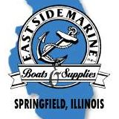 **O'SHEA**

**BUILDERS**

**Springfield Crappie Club**

**Tournament Application**

**Lake Springfield – Sail Boat Ramp**

Sun, April 5, 2020, 7:00 A.M. – 2:30 P.M.

Check-in: 6:30 A.M. – Sail Boat Ramp

$50.00 per boat (no refunds)

Takeoff by order that entries are received

Big Crappie Pot: $10 per boat

A life jacket must be worn at takeoff.

No alcohol during tournament hours while

on the water.

Afternoon Check-in: 2:30 p.m.

Must be in the Weigh-in line by 3:00 p.m.

Seven (7) Crappie – 10-inch

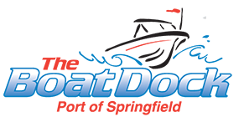1st to 4th (total $ received)

Make Checks Payable to: Springfield Crappie Club

PO BOX 2574

Springfield, IL 62708





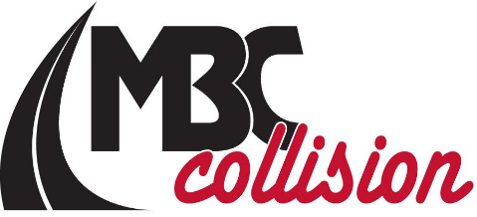



Name:_________________________ Partners Name:_______________________

Address:_______________________ PartnersAddress:______________________

City:______________Zip_________ City:__________________Zip___________

Phone:________________________ Phone:______________________________

Email:_________________________ Email:______________________________

Signature:______________________ Signature:___________________________

In signing this application, I hereby waive and release all contestants, sponsors and tournament officials from all claims of injury or damage incurred in connection with this tournament.

FYI, Tournament end times can be changed the morning of the tourney due to weather etc. by the tournament director. Please mark amount sent: Tournament Director:

 Arick Clark – 217-416-0706



 Entry fee: _________

Big Crappie: _________

Total Fee _________

