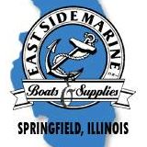

**Springfield Crappie Club**

**Tournament Application**

**Lake Shelbyville – Wilborn Creek**

Sat, May 16, 2020, 7:00 A.M. – 2:30 P.M.

Sun, May 17, 2020, 7:00 AM – 1:00 P.M.

Check-in: 6:30 A.M. – Wilborn Creek Boat Ramp

$80.00 per boat (no refunds)

Takeoff by order that entries are received

Big Crappie Pot: $20 per boat per day.

A life jacket must be worn at takeoff.

No alcohol during tournament hours while

on the water.

Check-in: 2:30 p.m. – Wilborn Creek

Must be in the Weigh-in line by

3:00 p.m. – Saturday 1:30 p.m. - Sunday

Seven (7) Crappie – 10-inch

1st to 4th (total $ received)

Make Checks Payable to: Springfield Crappie Club

PO BOX 2574

Springfield, IL 62708

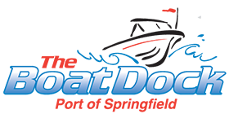









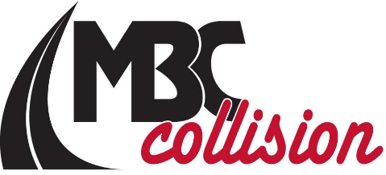

Name:_________________________ Partners Name:_______________________

Address:_______________________ PartnersAddress:______________________

City:______________Zip_________ City:__________________Zip___________

Phone:________________________ Phone:______________________________

Email:_________________________ Email:______________________________

Signature:______________________ Signature:___________________________

In signing this application, I hereby waive and release all contestants, sponsors and tournament officials from all claims of injury or damage incurred in connection with this tournament.

FYI, Tournament end times can be changed the morning of the tourney due to weather etc. by the tournament director. Please mark amount sent: Tournament Director:

 Arick Clark – 217-416-0706



 Entry fee: _________

Big Crappie: _____

Total Fee: ________

