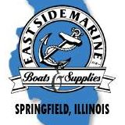**BY-PASS   
AUTO BODY**

**Spring Open Buddy**

**LAKE SANGCHRIS**

 **Crappie Tournament**

 SPRINGFIELD

CRAPPIE CLUB

**Sunday, March 22, 2020**

 7:00 A.M. – 2:30 P.M.

7 Crappie, 10-inch Limit

**East Boat Ramp**

Entry Fee - $50.00 per boat

Payback is 70% of Entry Fees Collected

Optional Big Crappie Pot

($10.00 per Boat Extra – 100% payback)

1 SPOT PAID FOR EVERY 5 BOATS

 EXAMPLE 30 BOATS PAYS 1st-6th

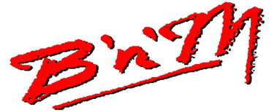



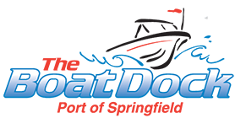

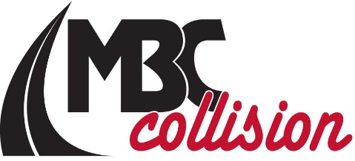

RULES AND REGULATIONS

TEAM TOURNAMENT (TWO PERSONS PER TEAM, ONE TEAM PER BOAT)

RULES: The following rules for the Tournament will be used. These rules will be interpreted solely by the Tournament Committee and all decision are final.

Live wells and bait well check between 6:00 and 6:30.

TOURNAMENT COMMITTEE: Tournament Committee shall consist of Springfield Crappie Club Board Members at the tournament.

ELIGIBILITY: All individuals who have paid the appropriate entry fee.

HEADQUARTERS/TIME/DATE: **East Boat Ramp, March 22, 2020**

Check-in at headquarters by 6:30 a.m. Fishing time will be from 7:00 a.m. to 2:30 p.m.

Fishing times can be adjusted by Tournament Director and will be announced the morning of the tournament. Example = weather, etc.

TACKLE AND EQUIPMENT: Live bait may be used. More than one pole may be used.

All Illinois Department of Natural Resources Laws and Regulations shall apply.

ENTRY FEE: Entries received by mail on or before Sunday, March 15, 2020. $50.00 per team. No Checks will be accepted after March 16, 2019.

Returned Checks will result in immediate disqualification. NO POST DATE CHECKS allowed.

(CASH ONLY DAY OF TOURNAMENT)

DEPARTURE: Departure will be in sequence in which entry fees are received. We reserve the right to adjust takeoff procedures and hours if necessary.

PAYBACK: 1 Spot for every 5 boats.

TIES: Ties will be broken by big fish weight. Big Fish tie will be broken by the earliest starting position.

PROTESTS: Protest must be filed in writing with the tournament committee within 30 minutes of the conclusion of the weigh-in.

DECISIONS ON PROTESTS: The Tournament Committee will decide all protests. All decisions are final.

PERMITTED FISHING LOCATIONS: Anywhere on the lake that is permitted by IDNR.

TOURNAMENT CANCELLATION: If the tournament is cancelled due to reasons of safety, etc, the entry fee will be refunded.

REFUNDS FOR ANY OTHER REASON WILL NOT BE MADE.

BOAT IDENTIFICATION: A contestant number must be available at all times during the tournament. Boats may not be trailered during the tournament.

ALL CONTESTANTS MUST FISH FROM A BOAT.

SAFETY AND SPORTMANSHIP: Safe Boating and fishing practices must be observed. Life Jackets must be worn at takeoff.

All IDNR Laws and Regulations shall apply. **NO ALCOHOL DURING TOURNAMENT WHILE ON THE WATER.**

SCORING: Total weight of Seven (7) crappie per team will determine winners. Crappie must measure at least TEN (10) inches long.

Any team bringing more than seven (7) or any crappie under 10 inches, to the scales will be disqualified.

Crappie brought to the scales for weigh-in must have been caught during tournament hours by the team bringing the fish to the scales.

Any frozen or mangles fish presented for weigh-in will result in disqualification.

Contestants must be in sight of their partners during the tournament hours and until they have weighed in.

Big crappie is determined by weight.

BIG CRAPPIE: 1st Place pays 100% of the Big CRAPPIE pot collected.

WEIGH-IN LINE: Location of the weigh-in area will be announced the day of the tournament. No team will be allowed to get into the line until after 3:00.

Afternoon Check-in: EAST BOAT RAMP by 2:30 p.m.

OFFICIAL CLOCK: Tournament Committee shall appoint one of its members to maintain an Official Clock.

The Tournament shall operate on the time of that official clock.

=========PLEASE PRINT LEGIBLY AND COMPLETE ALL BLANKS-----------------CUT ALONG THIS LINE AND MAIL===========================

**At the request of the tournament committee, All tournament participants agree to submit to and pass a truth test prior to receipt of any prize.**

We____________________________(boater) and _____________________________(non-boater)

Signature Signature

**Do hereby agree to release Springfield Crappie Club from any and all liability as a result of our participation in the crappie tournament to be held on March 23, 2019 at Lake Sangchris. We understand that we are participating in this at our own risk and that we are assuming all risk incident to said Tournament including the travel to and from the Tournament. , the participation in the Tournament, and all other activities to the Tournament that we choose to participate in. We indemnify and hold harmless the Springfield Crappie Club from any and all liability as a result of our participation and waive any claim for liability that we might have of any kind or nature against the said Springfield Crappie Club.**

**This Release and Indemnification made and entered this __________day of _________________________, 2019.**

**Print Name_________________________________ Print Name________________________________________**

**Boater Non-Boater**

**Address _________________________________ Address ________________________________________**

**_________________________________________ __________________________________________________**

**Phone (______)__________________________ Phone (______)_________________________________**

**Email _________________________________ Email ________________________________________**

**ENTRY FEE: $50.00 Check here if entering optional Big Crappie Pot:________($10.00 Extra per boat)**

**Make checks payable to: Springfield Crappie Club ------------------------------------------------------**

**| For Office use only |**

**Mail Check and entry form to: Springfield Crappie Club | |**

**PO BOX 2574 | Received ____________ #_________|**

**Springfield, IL 62708 ------------------------------------------------------**

**----------------------------------Photocopies are acceptable. Give them to your friends-----------------------------------------------**

**---------------------------------For Further information: Call Arick Clark – 217-416-0706----------------------------------------------**